CURRICULUM VITAE 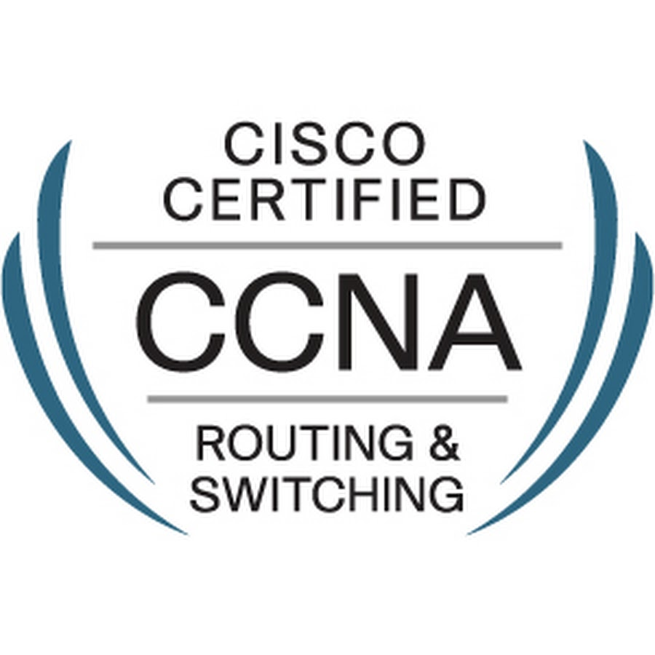 Cisco ID – CSCO13092957
Shubham Thakur
NEW-T-77,Om Vihar,
Uttam Nagar,
New Delhi - 110059
#9716236651
Shubhamdec05@gmail.com

CAREER OBJECTIVE
Looking forward to join a professional organization that provides ample opportunities to enhance technical knowledge and skills.

Professional Qualification
2013: Completed a Fifteen months Professional Diploma in Hardware and Networking (JCHNP) from Jetking, Vikas Puri.

2016: Completed CCNA (Cisco Certified Network Associate) certification & Cisco ID – CSCO13092957

TECHNICAL SKILLS
HARDWARE
- Knowledge of Computer Peripherals & Assembling of PCs.
- Troubleshooting of common problems of computer; like No display & Hanging Problem
- Installation & Configuration of any Windows & Linux Operating System & Software
- Prevention of Virus attacks by using Antivirus Software and Firewalls.
- Knowledge of Smart Classes instruments; like Projectors, Digital Boards, U-pointer & visualizer.
- Troubleshooting.
NETWORKING
- Configuration and troubleshooting of Outlook and Windows Mail.
- Providing Technical support for internet Problems.
- Managing and Administrating all user domains and accounts.
- Basic knowledge of OSI Model.
- Installation, Configuration, Maintenance and Troubleshooting of DNS, DHCP.
- Designing IP addressing scheme using subnets. Installing, Configuring and Troubleshooting of Routers and Switches.
- Sound knowledge of routing protocols - RIP V1/V2, OSPF, IGRP and EIGRP
- Handling problems related to FTP Services over 100 users
- Subnetting.
SOFTWARE.
- Basic Knowledge of MS Office: 2003 & 2007 (Word, Excel and PowerPoint).
- Software installation – technical support (Verbal or Remote).

EDUCATIONAL QUALIFICATIONS
Academic Qualifications

- Pursuing B.C.A 3rd year from IGNOU.
- 2012: Completed class 12th From U.P Board.
- 2010: Completed class 10th From C.B.S.E Delhi.

WORK EXPERIENCE
Working as a Technical Support Engineer Mbd Alchemie Pvt Ltd. since Nov’2014
- Assembling the Computers & Laptops part replacement.
- Solving the regular upcoming Hardware & Networking issues and maintenance.
- Providing Technical support for Smart Classes.
- Connecting the printers with the desktops & laptops.
- Provide L1 support on AR app.
- Problem analysis, use of judgment and ability to solve problems efficiently.
- Provide training to staff at the customer location.
- Plan, develop and present training to increase overall capabilities of users of the installed computer equipment.
- Setting up computer labs for schools and clients.
- Responsible for all backups of the company.
- Operating Systems (OS) installation / re-installation, upgrades and patches for desktops
- Software installations such as MS-Office, Acrobat Reader and Configure Mail account of clients, Installation of VS.Net 2005/2008 and Install Adobe Software’s such as Photoshop, Flash, Dream wear, PageMaker etc.
- Manage Users folders permissions.
- Desktops Configuration - Network, mail client, internet.
- Maintaining and attending day-to-day user's problem calls.

Worked as a Technical Engineer Eclat Infocom Pvt Ltd. (From Mar’2014 till Sep’2014)
- Assembling & disassembling the computers.
- Manufacture the Podiums. Like (Wooden, Acrylic, Metallic podiums).
- Provide the services of digital gagets like Student Response System, Visualisers, Interactive MobiPad & uPointer.
Worked as a Technical Engineer Shivam Enterprises. (From Oct’2012 till Sep’2013)
- Assembling & disassembling the computers.
- Day to Day Documentation Work
- Problem analysis and problem solving
- Organizational skills and customer service orientation

KEY ACHIEVEMENTS
- Certified in Participation on “Debate Competition” conducted by JETKING, Vikaspuri office in Engineer’s Week Celebration on 14th August, 2012.

- Awarded as performer of the Great Work Moment on November’ 2019

STRENGTHS
- Meticulous.

ADDITIONAL INFORMATION

Name : Shubham Thakur
Date of Birth : 05th Dec, 1995
Father’s Name : Mr. Narender Pal Singh
Nationality : Indian
Marital Status : Unmarried
Hobbies & Interests : Playing cricket
Language : English & Hindi

Declaration:
I hereby declare that all the information given above is correct according to the best of my knowledge and belief.

Date:
(Shubham Thakur)

